- The Monetary Policy Committee voted to cut Bank Rate by 25bps to 3.75% at its meeting this week. The vote split was tight, with Governor Andrew Bailey again casting the decisive vote. The MPC's messaging suggested the balance of risks to inflation had tilted in a dovish direction, but that December's loosening is unlikely to be the start of a rapid series of cuts.
- We're sticking with our call that the MPC will deliver two 25bp cuts in 2026. The committee's cautious guidance and emphasis on the strength of forward-looking wage indicators suggests a majority of members will be prepared to wait until the end-April meeting to cut again, by which time they will have a clearer view of the size of the new year pay awards.
In a hectic week of economic releases, the Bank of England's December monetary policy decision took centre stage. Coming into the December meeting, we thought the prospect of a 25bp rate cut being delivered alongside cautious guidance was likely. In the event, the Monetary Policy Committee voted 5-4 to cut Bank Rate by 25bps to 3.75%. The four dissenters voted to keep rates unchanged at 4%.
Though the decision was widely expected, the narrow vote split highlighted how divided the committee remains. As we anticipated, Governor Andrew Bailey was again the swing voter, switching to support a cut after advocating for a hold at the last meeting in November.
Bailey framed his vote as being consistent with further evidence of slack building in the economy and that disinflation is now more established. Indeed, the Governor had intimated in November's minutes that he wanted to see softer inflation before cutting again, and this week's inflation release confirmed that headline inflation had fallen to 3.2% in November, well below the 3.8% rate seen ahead of the November meeting.
With respect to the rates outlook, the minutes sent two key messages. First, the balance of risks to inflation has tilted in a dovish direction, with the BoE's high inflation scenario less likely to materialise, while its weak demand scenario remains a live risk. And second, the committee noted in its collective statement that "judgements around further policy easing will become a closer call", which signalled that this is unlikely to be the start of a rapid series of cuts.
Chart 1: The MPC's favoured measure of underlying services inflation has edged high in recent months
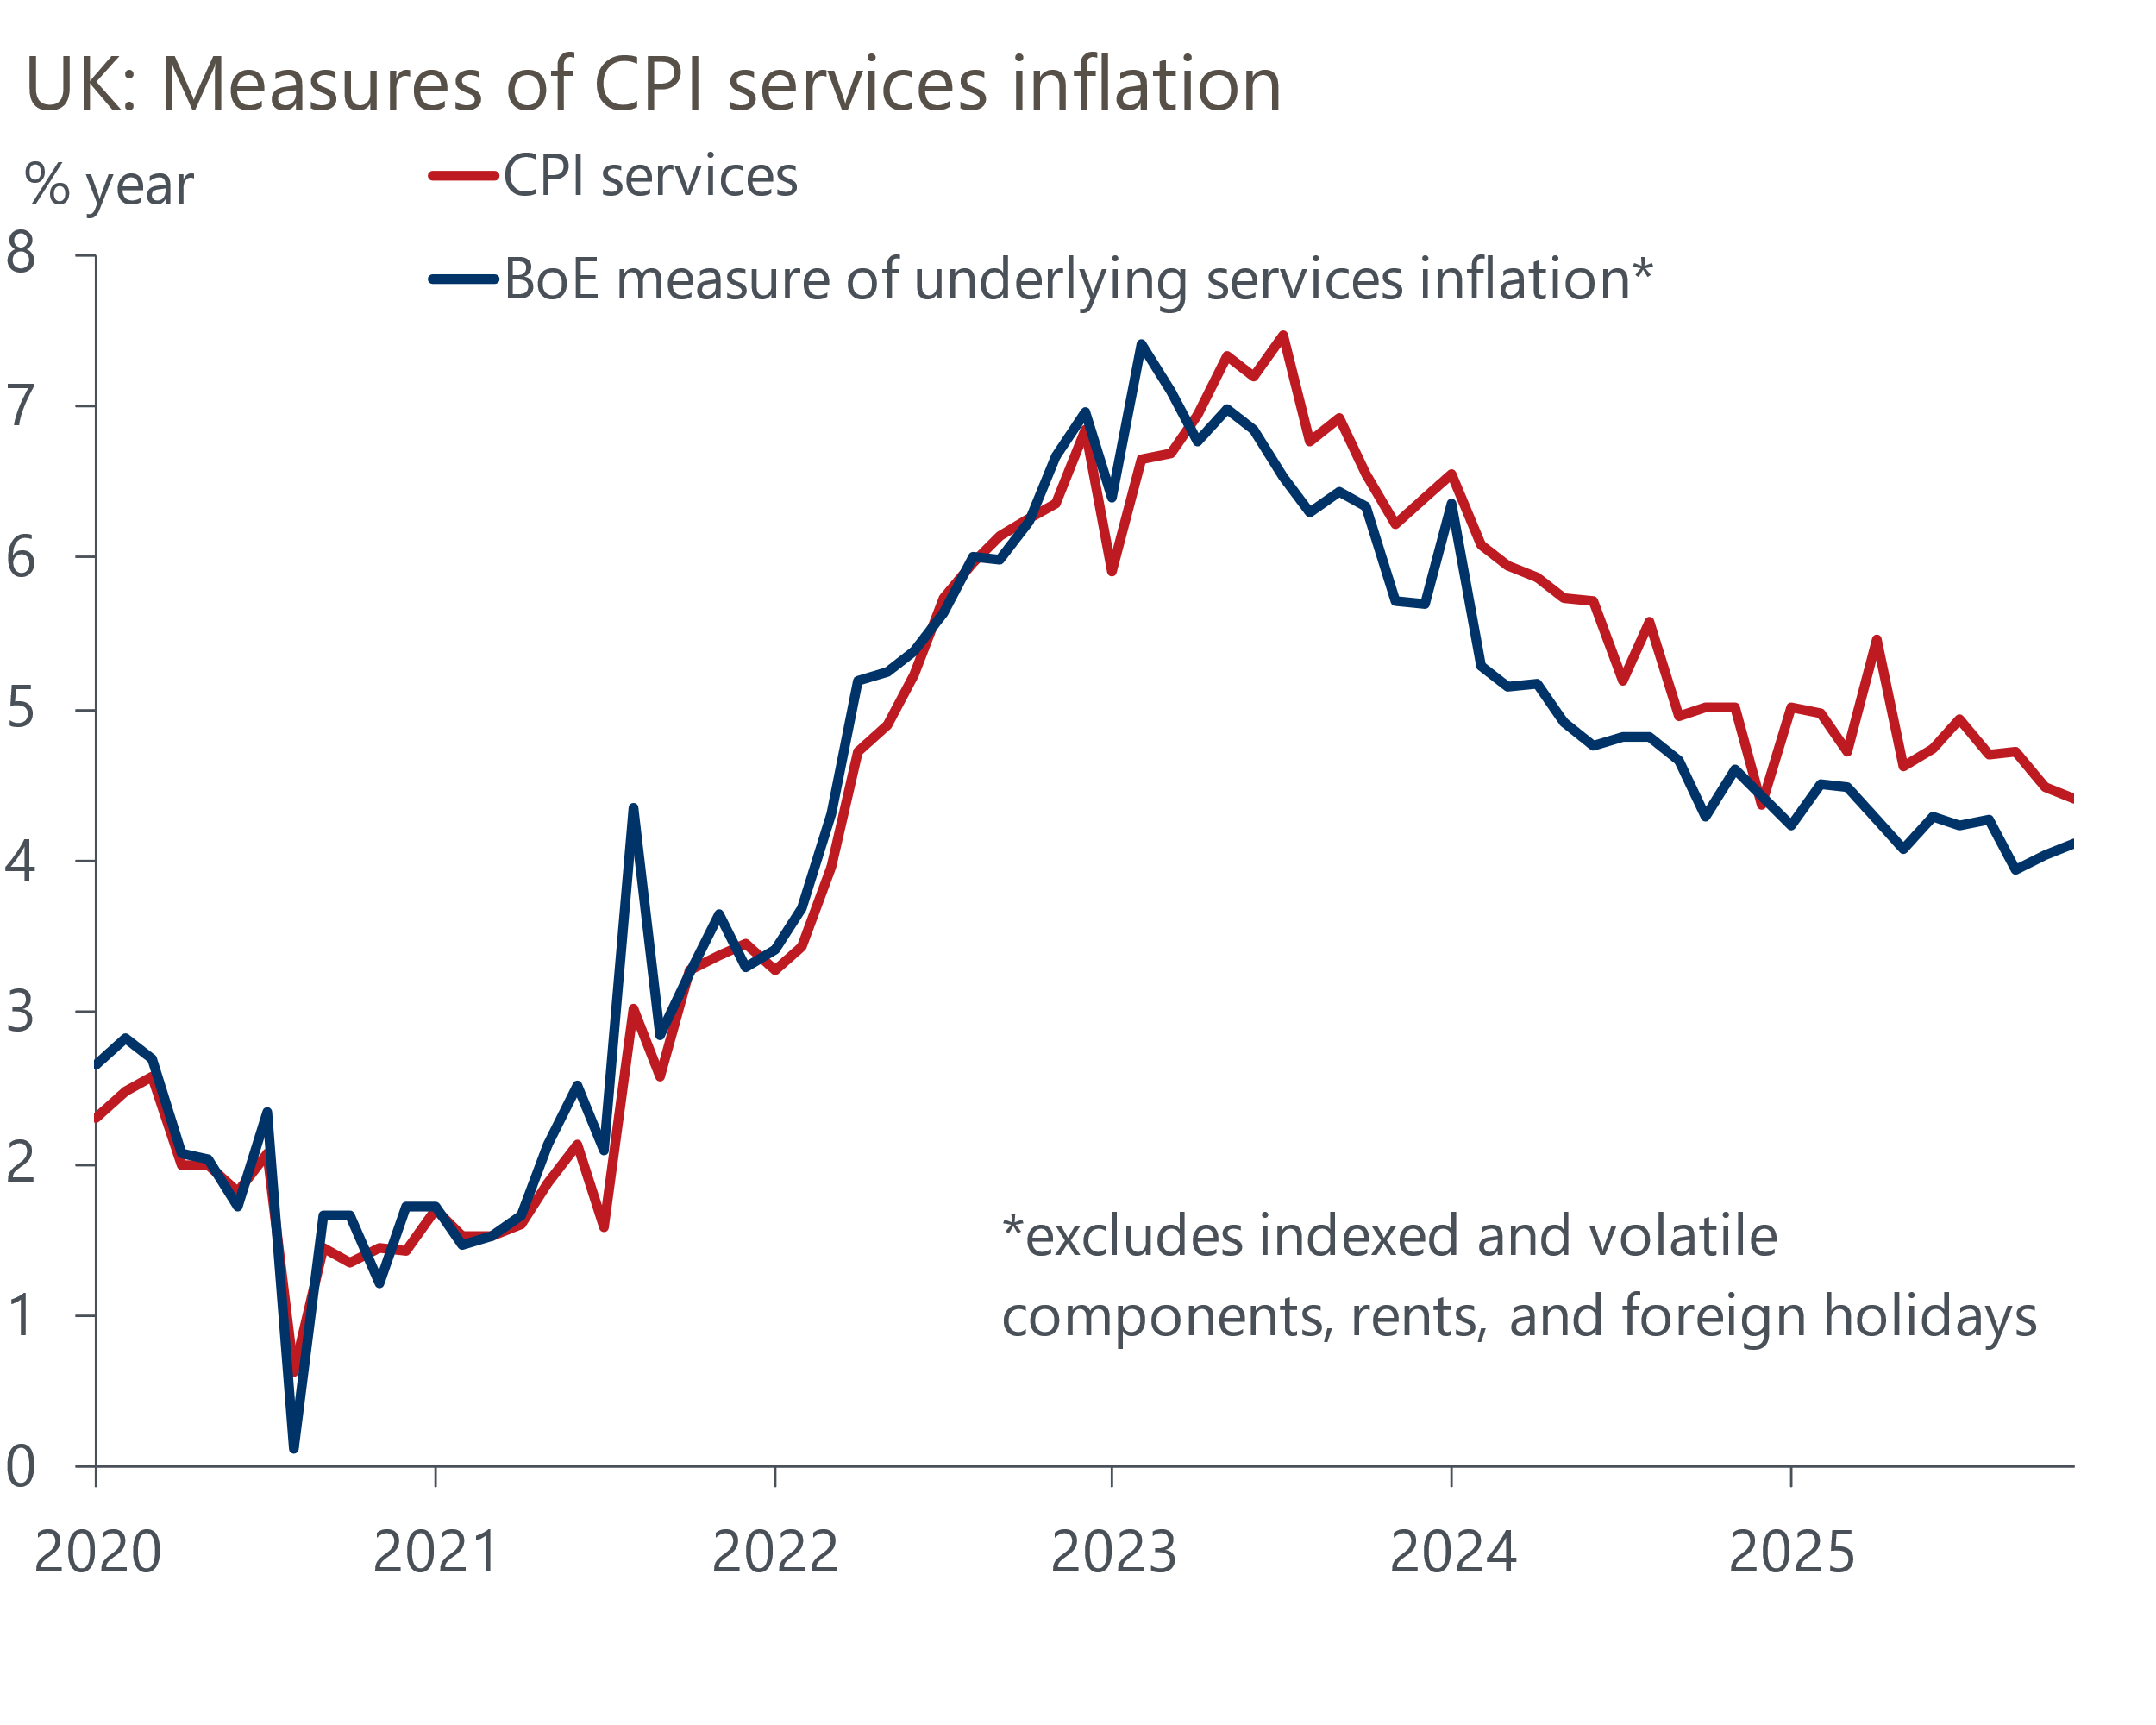
Source: Oxford Economics calculations using data from Haver Analytics

That December's guidance continued to point to a gradual path downward for Bank Rate partly reflects the notion that the MPC is cautiously feeling its way to a neutral policy rate, and that there is a range of views on what that level is. It also reflects uncertainty over whether the degree of slack emerging is sufficient to sustainably return inflation to target.
Though the two lower inflation readings since the November meeting fulfilled Bailey's criteria for cutting, neither provided much concrete evidence that underlying price pressures were cooling. The downshift in October's inflation data was fully accounted for by Ofgem's new energy price cap. Meanwhile, the slowdown in this week's data for November was primarily driven by a combination of base effects from higher tobacco duties, the timing of Black Friday discounting, and movements in notoriously volatile categories. Moreover, the MPC's favoured measure of underlying inflationary pressure in the key services sector has risen slightly in each of the past two inflation releases (Chart 1).
The minutes also referenced the committee's concerns that though this week's pay data continued to show momentum cooling quickly, forward-looking indicators of wage growth appear to have plateaued. Intelligence from the BoE's regional agents suggested that pay deals in early-2026 are likely to average 3.5%, which is higher than a level that would be consistent with the BoE achieving its inflation target over the medium-term. Similarly, data from the BoE's Decision Maker Panel suggests that year-ahead wage expectations remain elevated and have shown little progress this year (Chart 2).
Chart 2: Forward-looking measures of wage pressures appear to have stabilised at an elevated level
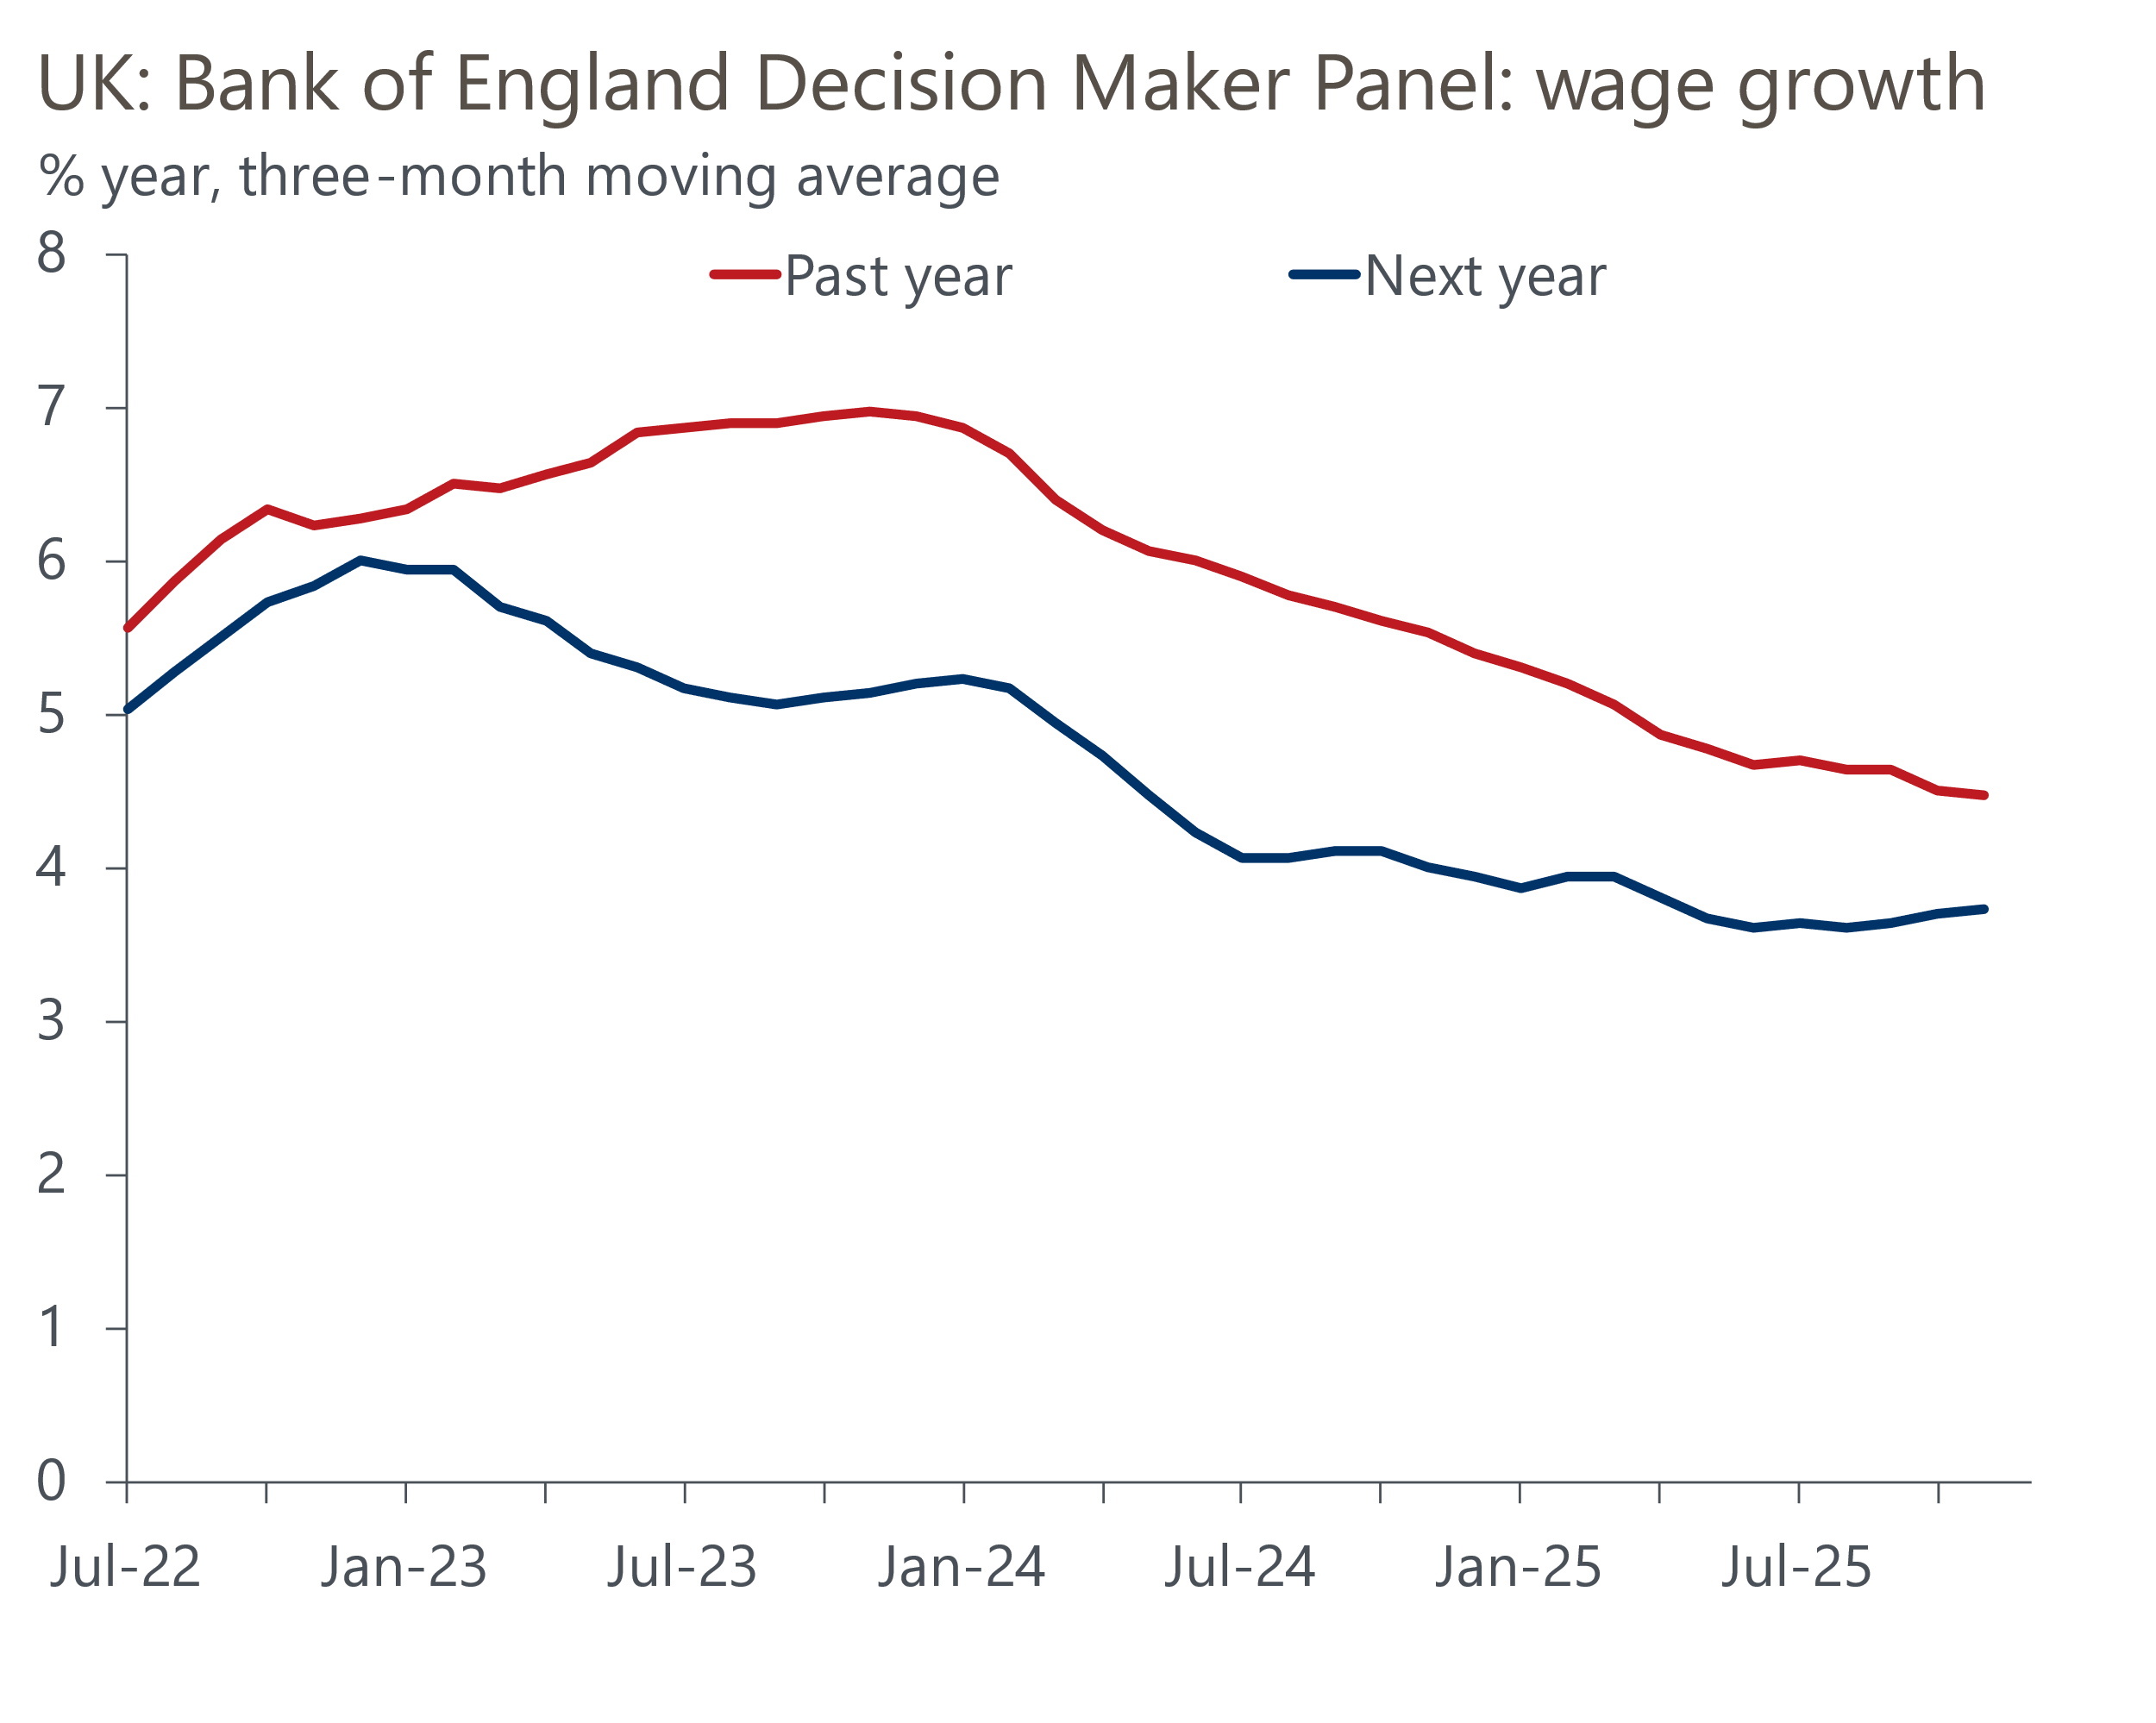
Source: Haver Analytics
In November, there was a clear dividing line between the dovish camp, who were concerned about weak growth and the deteriorating labour market, and the hawks, who were worried that structural shifts in inflation expectations and price setting make it more likely inflation will remain high, with Bailey somewhere in between. But the paragraphs summarising the views of individual MPC members in December's minutes suggest this landscape has shifted slightly. Though the committee's more hawkish members acknowledged that recent data had been softer, their concerns largely remained. But the dovish camp has now split, with the internal members – Bailey, Breeden, and Ramsden – much more cautious on the scope for further cuts and emphasising that their main focus is forward-looking pay indicators.
We're sticking with our call that the MPC will deliver two 25bp cuts in 2026, with Bank Rate ending next year at 3.25%.
Given the committee's cautious guidance, and that only one set of labour market and inflation releases will be published ahead of the February meeting, the prospect of back-to-back rate cuts looks unlikely. Instead, we think most committee members will be content with waiting until the end-April meeting to cut again. By that time, the BoE's agents will have delivered their full assessment of the new year pay deals, and the MPC will be able to assess whether this is materialising in the official data. Meanwhile, there should also be further evidence of weak growth and slack accumulating in the labour market. We expect the second of next year's cuts to come in November.

The week ahead
The Office for National Statistics will publish the national accounts for Q3 just before the UK breaks for Christmas. Last month's preliminary estimate reported that quarter-on-quarter growth slowed to just 0.1% in Q3. Meanwhile, the expenditure breakdown highlighted the absence of a sustainable growth driver, with weak consumer spending growth and another fall in business investment.
We will also get the first estimates of household income growth and the saving ratio. The momentum behind both consumer spending and real income growth looks very soft, so we expect the saving ratio to be little changed in Q2.
The first release of the new year will be the S&P Global manufacturing survey for December. The flash survey pointed to a modest rise in manufacturing activity, with the PMI of 51.2 representing a 15-month high, reflecting a pickup in production levels. Final readings can be prone to revisions, but we think December's final results are likely to come in close to the flash figures.
The following week will see the release of December's remaining S&P Global surveys. The flash survey reported an improvement in the services PMI to 52.1, from 51.3 in November, with stronger activity growth driven by an upturn in new orders. This lifted the composite PMI to 52.1, from 51.2, signalling a slightly faster pace of private sector activity growth. We expect the final survey to reiterate this picture, and show a shallower contraction in the construction PMI, after a particularly sharp drop in November.
After a slightly softer outturn in October, we think mortgage approvals inched up to 65,500 in November, from 65,000 a month earlier, with a small decline in quoted mortgage rates behind the improvement in demand. The data on secured lending flows should also have firmed, following the uptick in approvals over the early-autumn period. Therefore, we forecast that net mortgage lending rose to £5bn in November, from £4.3bn in October.
On the unsecured side, October's outturn for net lending was weaker, as stronger gross lending was more than offset by higher repayments. Though there's scope for gross lending to fall in November, a larger decline in repayments looks likely. As a result, we think net unsecured lending increased to £1.3bn in November, from £1.1bn in the previous month.
Table 1: Week ahead calendar
Date | Events | Period | Measure | Unit | Previous | Forecast
Dec 22 | GDP | Q3 | q/q | % | 0.1 | 0.1
Dec 22 | GDP | Q3 | y/y | % | 1.3 | 1.3
Dec 30 | Nationwide house prices | Dec | m/m | % | 0.3 | 0.1
Dec 30 | Nationwide house prices | Dec | y/y | % | 1.8 | 1.2
Jan 2 | S&P Global manufacturing | Dec | PMI | % bal | 51.2 | 51.2
Jan 5 | Mortgage approvals | Nov | Level | 000s | 65.0 | 65.5
Jan 5 | Mortgage lending | Nov | Net lending | £bn | 4.3 | 5.0
Jan 5 | Consumer credit | Nov | Net lending | £bn | 1.1 | 1.3
Jan 6 | S&P Global services | Dec | PMI | % bal | 52.1 | 52.1
Jan 6 | S&P Global composite | Dec | PMI | % bal | 52.1 | 52.1
Jan 7 | S&P Global construction | Dec | PMI | % bal | 39.4 | 44.5
Jan 8 | Halifax house prices | Dec | m/m | % | 0.0 | 0.2
Jan 8 | Halifax house prices | Dec | y/y | % | 0.7 | 1.1
Source: Oxford Economics
The next edition of UK Weekly Economic Briefing will be published on Friday January 9, 2026.

Key forecasts
Table 2: UK forecast overview
(Annual percentage changes unless specified)
 | 2023 | 2024 | 2025 | 2026 | 2027 | 2028
GDP | 0.3 | 1.1 | 1.4 | 1.0 | 1.4 | 1.5
Private consumption | -0.3 | -0.2 | 0.9 | 1.0 | 1.1 | 1.4
Fixed investment | 0.5 | 1.8 | 3.0 | 0.9 | 2.1 | 2.1
Government consumption | 2.1 | 3.4 | 2.0 | 2.0 | 1.7 | 1.4
Exports of goods and services | -2.3 | 0.6 | 2.8 | -0.4 | 1.0 | 1.3
Imports of goods and services | -1.6 | 2.6 | 3.6 | -0.4 | 1.2 | 1.4
Industrial production | -2.6 | -1.6 | -0.5 | -0.1 | 1.1 | 1.3
Consumer prices | 7.3 | 2.5 | 3.4 | 2.7 | 2.5 | 2.2
Unemployment rate (%) | 4.1 | 4.3 | 4.8 | 5.0 | 4.8 | 4.5
Current a/c balance (% of GDP) | -3.6 | -2.2 | -3.0 | -2.7 | -2.6 | -2.5
Government balance (% of GDP) | 5.2 | 5.2 | 5.0 | 3.9 | 3.3 | 2.8
Central bank policy rate (%, EOP) | 5.25 | 4.75 | 3.75 | 3.25 | 3.00 | 2.75
10yr govt. bond yield (%, EOP) | 3.54 | 4.57 | 4.60 | 4.39 | 3.89 | 3.65
Exchange rate (US$ per £, EOP) | 1.27 | 1.25 | 1.32 | 1.29 | 1.29 | 1.29
Exchange rate (euro per £, EOP) | 1.15 | 1.21 | 1.14 | 1.11 | 1.11 | 1.11
Source: Oxford Economics
Table 3: Quarterly forecasts for the UK
 | 2025 |  |  |  | 2026
 | Q1 | Q2 | Q3 | Q4 | Q1 | Q2 | Q3 | Q4
GDP (% year) | 1.8 | 1.4 | 1.3 | 1.2 | 0.8 | 0.8 | 1.0 | 1.2
CPI inflation (% year) | 2.8 | 3.5 | 3.8 | 3.6 | 3.4 | 2.4 | 2.5 | 2.5
Bank Rate (%, EOP) | 4.50 | 4.25 | 4.00 | 3.75 | 3.75 | 3.50 | 3.50 | 3.25
10yr gilt yield (%, EOP) | 4.70 | 4.48 | 4.70 | 4.60 | 4.60 | 4.57 | 4.49 | 4.39
US$ per £ (EOP) | 1.29 | 1.37 | 1.35 | 1.32 | 1.30 | 1.29 | 1.29 | 1.29
Euro per £ (EOP) | 1.20 | 1.17 | 1.15 | 1.14 | 1.12 | 1.11 | 1.11 | 1.11
Source: Oxford Economics

Latest Country Economic Forecast:
December 10, 2025

Recent publications

Data Insights
Public finances remain on a difficult path
Take November's retail sales data with a pinch of salt
Downside surprise for inflation supports December rate cut
Reduced uncertainty after the Budget boosted December's PMIs
Cooling labour market slows wage growth

Research Briefings
MPC cuts, but emphasises the need for caution in 2026
MPC preview – Close call, but probably a cut
Why are household savings higher? Evidence from microdata
Key themes 2026 – Sluggish growth and fiscal worries
Budget papers over the cracks but can't hide the fiscal risks

Contacts

Oxford Economics' UK team
- Andrew Goodwin - Chief UK Economist - agoodwin@oxfordeconomics.com
- Edward Allenby - Senior UK Economist - eallenby@oxfordeconomics.com

